WordNet, Supersenses and WSD

Source: https://people.ischool.berkeley.edu/~dbamman/nlp20_slides/19_word_senses.pdf

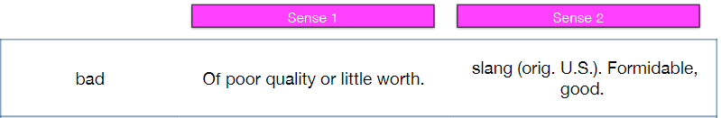
Word Senses
- Polysemy: multiple meanings
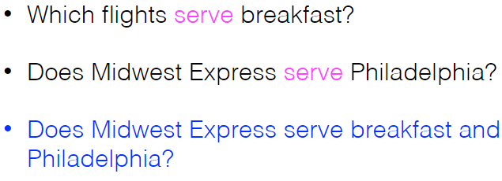
- Zeugma: conjunction of antagonistic readings to test distinct sense
- Sense relationships
  - Synonymy: couch→ sofa
  - Antonymy: long → short
  - Hyponymy: car →vehicle
  - Meronymy: wheel→ car

Word Sense Disambiguation
- Dictionary method (Lesk)
  - Predict sense from overlap between context and dictionary gloss
- Semi-supervised learning
  - Create seeds → train classifier on labeled examples → re-label and keep high-confidence instances
- Dataset
  - WordNet for nouns/advers/adjectives/adverbs arranged in synsets
  - Semcor: corpus tagged using WordNet

